208pix/14pix=bricks = 14.857bricks

American Brick = (8x4x2.25) CONFIRMED by 14/4 ratio of pixel brick~3.5 very close to 8/2.25~3.5555

Thus multiply by

http://www.hintsandthings.co.uk/workshop/bricks.htm

203mm or 0.203m or 0.0203dekameters/brick

Yields a fire escape width of:

0.3016dekameters.

Height calc:

678-473 for height in pixels=205

In bricks that is 14.643

In decameters this is .2973dekameters.

Approximately a .30dekameter square. (number I might use).
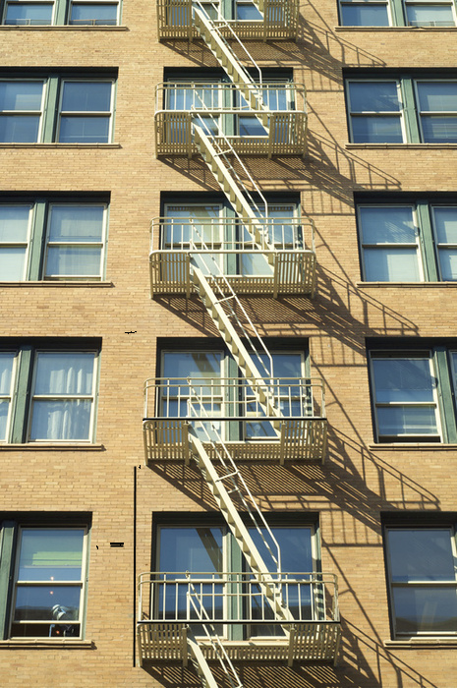
Black lines are how I determined pixel length.

